NYSSLS Daily Lesson Plan
Instructional Unit:  Weather and Climate  Air masses fronts and weather  LESSON: Winds and the Coriolis effect |  |  |  |  | Period(s) of Unit:  6 Periods | Date:
Materials/Resources/Links:  The Air Pressure and Wind - Javalab  Coriolis Effect Gizmo : ExploreLearning |  |  |  |  |  | Course:  Earth and Space Science
Special Notes for Lesson:

ANCHORING PHENOMINON: Why are there winds on Earth?

Standards:
Science and Engineering Practices  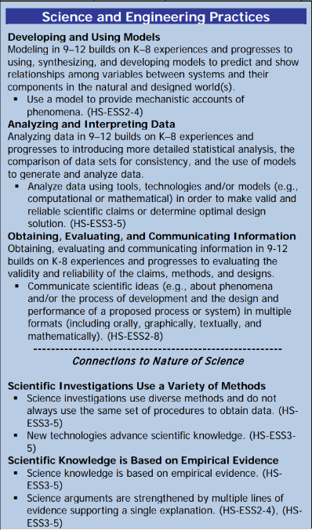 |  | Disciplinary Core Idea(s)  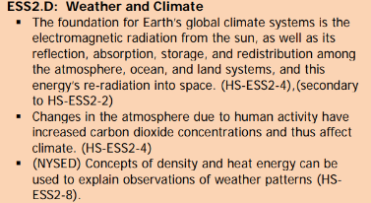 |  |  |  | Cross Cutting Concepts  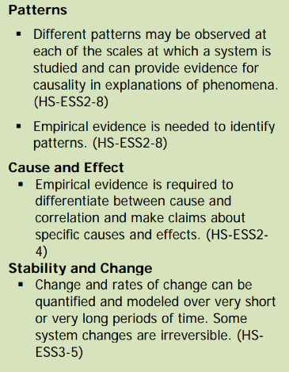
Performance Level
NYS Level 5 | NYS Level 4 |  |  | NYS Level 3 | NYS Level 2 | NYS Level 1
Collect and analyze global and regional weather data using tools, technologies, and /or models to communicate in multiple formats how the movement and interactions of airmasses result in changes in weather conditions. | Evaluate data and communicate information to explain how the movement and interactions of air masses result in changes in weather conditions |  |  | Evaluate data and communicate information to identify patterns of movement and/or the resulting changes in weather conditions. | Use data to identify the patterns of movement or the interactions of air masses and the resulting change in weather conditions  or to identify factors that drive the movement of air masses or from given weather conditions, identify evidence from maps that support these conditions. | Use data and/or patterns of movement and interactions of air masses to identify the resulting changes in weather conditions or identify one factor that drives the movement of air masses or from those provided, use evidence from maps to account for weather conditions or given weather conditions, identify evidence found on maps that account for one of these conditions.
Clarification Statement  Examples of evidence sources could include station models, surface weather maps, satellite images, radar and accepted forecast models. Emphasis should focus on communicating how the uneven heating of the Earth’s surface at frontal boundaries and resulting weather phenomena. |  |  |  |  | Assessment Boundary  Analysis is limited to surface weather maps and general weather patterns associated with High and Low pressure systems
Connection to Anchoring Phenomenon:

Winds are an essential part of understanding weather and changes in weather, movement of air masses, fronts and weather forecasting.

Essential Question(s):

Why are there winds on Earth?

When the balloon is filled and the air comes out describe the motion of the air. What is causing the air to move.

How would air move on a pressure weather map?

Where would the high and low pressure areas be on the global winds map.

Why do don’t winds move in straight lines?

Instructional Strategies & Learning Tasks: Engage, Explore, Explain, Elaborate, Evaluate
Engage: images, video clip or data… |  |  | Students will be shown a video of winds, such as a hurricane or storm.
Explore: Students investigate, experiment, hands-on activity…. |  |  | Students will be given a balloon and asked to create a wind with the balloon. They will be asked to draw a picture that shows the movement of air. The students will also brainstorm why the air only moves one way.  Students will also explore the movement of a projectile by playing the Coriolis effect gizmo
Explain: Students share their observations and evidence to explain their understanding…possible whole group/class discussion… |  |  | The class will discuss the motion of air in relation to the balloon. The concept of air moving from high to low pressure will be established.  An air pressure weather map will be presented. Students will determine the movement of air based on the High and Low pressure areas.  A global wind belt diagram will be presented with arrows showing the movement of air. Students will determine the High and Low pressure latitudes.  The reason for curved winds will further explained by the teacher as well as observing what occurred with the gizmo.
Elaborate: Students apply the science concepts they’ve just learned… |  |  | Students will apply the movement of air in the balloon to air movement on a weather map  Students will apply the Coriolis gizmo to the reason why winds actually move in curved paths
Evaluate (Formative Assessment): Student learning is evaluated. |  |  | Students will be evaluated based on their answers to questions and a quiz or a test

Copy and paste student worksheets below:

